Contents
(1) Conceptual Design 1
1.1 High-level physical view 1
1.2 Physical elements and their arrangements 1
(2) Detailed Design 2
2.1 Preliminary Weight Estimation 2
2.2 Thrust Requirements Estimation 2
2.3 Propulsion System Selection 2
2.3.1 Motor 3
2.3.2 ESC (Electronic Speed Controller) 3
2.3.3 Propeller 4
2.4 UAS Sizing 4
2.4.1 Wheelbase 4
2.4.2 Rotor Arm Length 4
2.4.3 Hub Size 5
2.4.4 Propeller Clearance 5
2.4.5 Landing Gear Dimensions 5
2.5 UAS Performance Estimation 5
2.5.1 Power Requirements 5
2.5.2 Battery Selection 6
2.5.3 Endurance Estimation 6
2.6 Material Selection 6
2.7 Subsystem Selection 7
2.7.1 Communication System 7
2.7.2 Control & Navigation System 8
2.7.3 Avionics and sensors 12
2.8 Center of Gravity (C.G.) Estimation & Stability Analysis 12
2.9 Preliminary CAD Model 14
2.10 Computational Analysis 15
2.11 Optimized Final Design 18
2.11.1 Final CAD model 18
2.11.2 Final 2D drafting 19
2.11.3 Updated C.G. analysis 19
2.12 Detailed Weight Breakdown & C.G. Analysis 20
2.12 UAS Performance Recalculation 22
2.12.1 Thrust-to-weight ratio 22
2.12.2 Power requirements for the mission 22
2.12.3 Endurance Calculation 23
(3) Final UAS Specifications and Bill of Materials (BoM) 23
(4) Methodology for Autonomous Operations 24
4.1 Detailed Methodology for Implementing Autonomous Flight 24
4.2 Surveying Method and Autonomous Data Collection 24
4.3 Techniques for Autonomous Object or Target Identification 24
4.4 Disaster Management and Response 25
(5) Summary of Innovations 26
5.1 Payload box with Gyroscope 26
(6) References 28

(1) Conceptual Design

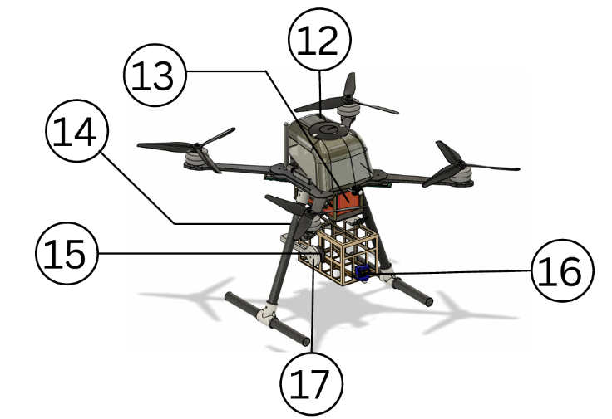
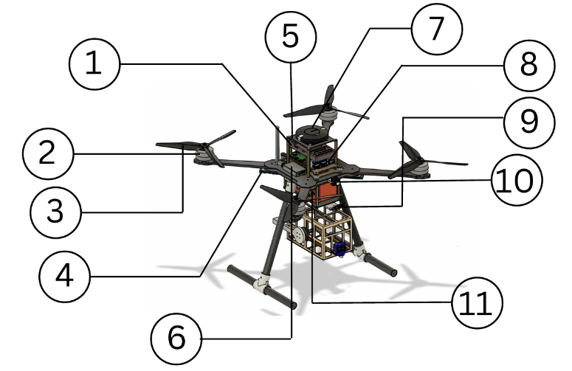
1.1 High-level physical view

1.2 Physical elements and their arrangements
S. no. | Description
1. | Flight Controller Pixhawk Cube Orange+
2. | Motor Hobbywing X6 Plus 150KV
3. | Propeller 2480
4. | ESC In-built In motor
5. | T10 TX RX
6. | CUAV C-RTK 2 HP GNSS
7. | Flight Computer Raspberry Pi 5 8GB
8. | 25200mAh 2*6S Battery
9. | Servo Motor MG995
10. | Power Distribution Board PDB-200A

(2) Detailed Design

2.1 Preliminary Weight Estimation
In this section, we present the method we used for the preliminary weight estimation of our UAV. We achieved this by analyzing the weight of each individual component in our design and cross-verifying these values with reference datasets. This approach allowed us to ensure accuracy and reliability in our total weight calculation, which is critical for performance, flight time, and payload capacity planning.
Given below are the preliminary weight estimation of our UAV:
Components | No. of Units | Unit Weight  (in grams) | Total Weight  (in grams)
Flight Controller | 1 | 73 | 73
BLDC Motor | 4 | 790 | 3160
Propeller | 4 | 115 | 460
Receiver | 1 | 17 | 17
RTK GPS | 1 | 40 | 52
Servo Motor | 1 | 9 | 9
Battery | 1
Frame + Landing Gear | 1
Gimbal | 1 | ~80 | ~80
Payload Box | 1 | 1340 | 1340
 | Total Weight |  | ~

2.2 Thrust Requirements Estimation
To ensure stable lift-off, efficient hovering, and reliable mission execution, we analyzed the thrust-to-weight ratio of our UAV. The system was evaluated based on its structural weight, payload, and propulsion capabilities.
Parameter | Value
Takeoff Weight | ~2100 g
Thrust per Motor | ~2000 g
Total Thrust | ~8000 g
Thrust-to-Weight Ratio | ~3.8:1

2.3 Propulsion System Selection
The propulsion system is one of the most critical subsystems in a drone, directly influencing its performance, efficiency, and mission capability. Selecting the appropriate propulsion system involves careful consideration of the drone's intended application, weight, endurance, and operating conditions.
Given below are the key components of the propulsion system:

2.3.1 Motor
The propulsion system design began with the selection of a motor suitable for a multi-rotor UAV intended for disaster management operations. After evaluating various high-power propulsion options, the Hobbywing X6 Plus 150KV brushless motor was selected for its high torque output, reliability, and efficient performance with large-diameter propellers. The low-KV configuration enables stable lift at lower rotational speeds, improving flight efficiency, endurance, and control, which are essential for precise maneuvering and payload delivery in emergency response missions
Hobbywing X6 plus (150 KV) Specification:
Specification
Max Thrust | 11.8kg/Axis (46V, Sea Level)
Weight | 790g
Rated Power Input | 700W
Rated Power Output | 580W
Recommended Battery | 12-14S(LiPo)
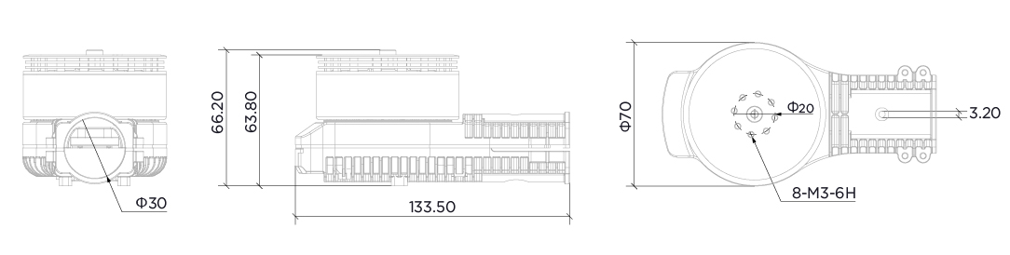
2D Drawing of Motor

2.3.2 ESC (Electronic Speed Controller)
An Electronic Speed Controller (ESC) regulates power delivery from the battery to the motor based on commands from the flight controller, enabling precise control of motor speed and thrust. In this design, the ESC is integrated With the Hobbywing X6 Plus motor, eliminating the need for an external unit and reducing wiring complexity. The in-built ESC ensures smooth throttle response, efficient power management, and reliable performance during high-load and payload-carrying operations.
ESC Specification:
Specification
PWM Input Signal Level | 3.3V/5V
Throttle Signal Frequency | 50-500Hz
Operating Pulse Width | 1050-1950us (Fixed or cannot be Programmed)
Max. Input Voltage | 61V
Max. Input Current | 80A (Non-hermetic Ambient Temperature 60°C)
BEC | No

2.3.3 Propeller
Propellers convert motor rotation into thrust by accelerating airflow. MFP 24×8.0 propellers are selected for their large diameter, enabling efficient lift generation at lower RPMs. This improves flight efficiency and stability, making them well-suited for payload-carrying disaster management operations.
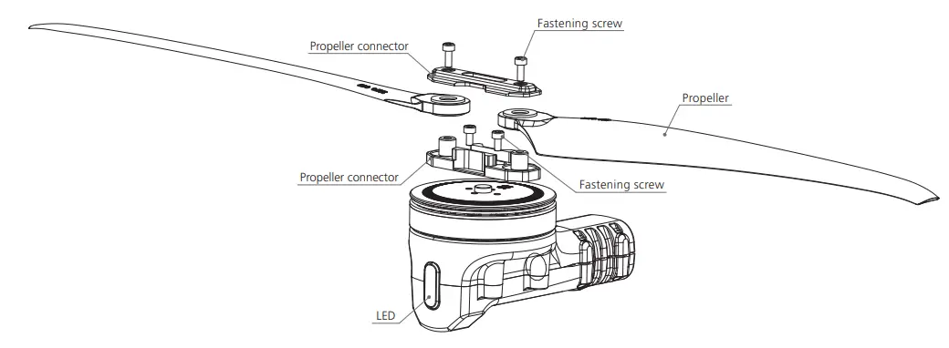
2D Drawing of Propeller

2.4 UAS Sizing
UAS sizing involves selecting the right drone dimensions and components based on its mission and payload to ensure optimal performance, stability, and flight time.

2.4.1 Wheelbase
The wheelbase is the distance between opposite motors and defines the drone's overall size. For our UAV, a ~1180 mm wheelbase offers a balanced platform for stable flight and efficient thrust.
Drawing for Wheelbase

2.4.2 Rotor Arm Length
The rotor arm length of our UAV is ~190 mm, providing the necessary clearance for optimal propeller size and efficient thrust generation.
Drawing for Rotor Arm Length

2.4.3 Hub Size
The drone’s hub size, measured diagonally between motor mounts, is about ~15.5 mm by ~20 mm, ensuring secure motor fit and stable flight.
Drawing for Hub Size

2.4.4 Propeller Clearance
Propeller clearance is the minimum space between propellers and the drone frame or components to prevent obstruction. Our drone has ~45 mm clearance from body and ~121 mm between propellers for safe, efficient operation.
Drawing for Propeller Clearance

2.4.5 Landing Gear Dimensions
For our drone, the Ground Clearence is ~193 mm, Landing Gear Length is ~213 mm providing sufficient clearance from the ground.
Drawing for Landing Gear Dimensions

2.5 UAS Performance Estimation
UAS Performance Estimation analyzes power, battery, and flight time to ensure efficient, safe operation. With our chosen battery and motors, the UAV offers stable performance and adequate flight time for its tasks.

2.5.1 Power Requirements
S. no. | Components | Name | Operating Voltage  (V) | Operating Current (A) | Power Consumption (w)
1 | Flight Controller
2 | BLDC Motors (x4)
3 | ESC
4 | Receiver
5 | Telemetry
6 | GPS
7 | Flight Computer
 | Total…………...

2.5.2 Battery Selection
Battery selection is crucial for a drone’s flight time, efficiency, and performance.
We chose a 25200mAh 4S (25V) 6*2LiPo battery, providing enough voltage and steady current for our motor and ESC.
Specification
Model | 6S
Capacity | 25200mAh
C Rating | 11C
Max. Continuous Discharge
Max. Voltage
Normal Voltage

2.5.3 Endurance Estimation
UAV endurance is the total flight time on one battery charge, affected by drone size, weight, payload, and power management.
The drone draws about 27A (shown on Mission Planner) with a 2kg weight. To achieve a minimum 10-minute flight time, this battery balances weight and capacity, ensuring reliable endurance for aerial tasks.

The Estimated calculation for endurance is hereby: -
Endurance (hrs.) = Battery Capacity (Ah) / Current Drawn (A)
Endurance (min.) = (5.2(Ah) / 27(A)) * 60 = 11.5 min

2.6 Material Selection
Material selection focuses on achieving a balance between strength, weight, and durability. PETG, PLA+, and ABS are used for structural components due to their good mechanical properties and ease of fabrication. Carbon Fiber and PLA-CF are selected for high-strength, load-bearing parts, while TPU is used for flexible and vibration-damping components to improve impact resistance and protect onboard electronics.

2.7 Subsystem Selection

2.7.1 Communication System
Communication System in a drone enables data exchange between the UAV and ground control for remote control and real-time monitoring.
(I) Skydroid T10
(Transmitter)
A handheld device used by the pilot to send control signals (throttle, pitch, roll, yaw) to the drone.
Parameter | Specification
Model | Skydroid T10
Channels | 10
Operating Frequency | 2.4GHz (2.400–2.4835 GHz)
Communication Protocol | New FHSS
Operating Voltage | 4.2 V
Battery Capacity | 4000 mAh (built-in)
Operating Time | Up to 20 hours
Telemetry Support | Yes
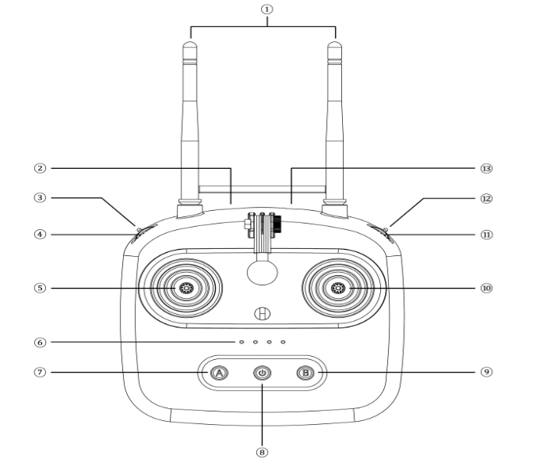
we are using The Radiomaster T10 transmitter is selected for its long-range communication capability, stable telemetry support, and precise control, making it well-suited for reliable UAV operation during mission-critical flights.
2D Drawing of Transmitter

(II) T10 (Receiver)
The Skydroid R10 receiver is selected for its stable long-range communication, telemetry support, and multi-signal output compatibility, ensuring reliable command and control during mission-critical UAV operations.2D Drawing of Receiver
Specification
Dimensions | 50 × 31 × 12 mm
Weight | ~20g
Channels | 10
Operating Frequency | 2.4 GHz
Operating Voltage | 4.5 – 5.5 V
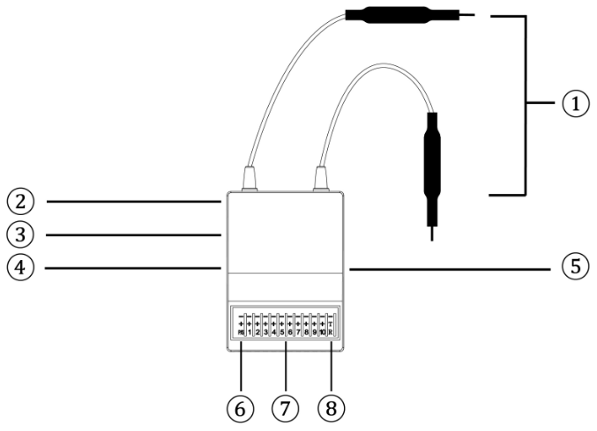

2.7.2 Control & Navigation System
(I) Pixhawk Cube Orange plus (Flight Controller)
The Pixhawk Cube Orange is a high-performance flight controller designed for reliable and safe UAV operations. It features a dual-processor architecture with a dedicated failsafe co-processor and redundant sensor systems, ensuring stable flight control, fault tolerance, and accurate navigation for mission-critical applications.
Category | Specification | Category | Specification
Main Processor | STM32H757 (32-bit ARM Cortex-M7) | Flash memory | 2MB
Clock Speed | 400MHz | IMU Sensors | 3×Accelerometer + Gyroscope (ICM42688P, ICM20948, ICM20649)
Ram | 1 MB | Compass | ICM20948
Barometer | 2× MS5611 | Input Voltage | 4.1V - 5.7V
Cube Dimensions | 38.25 × 38.25 × 22.3 mm | Carrier Board Dimensions | 94.5 × 44.3 × 17.3 mm
2D Drawing of Pixhawk
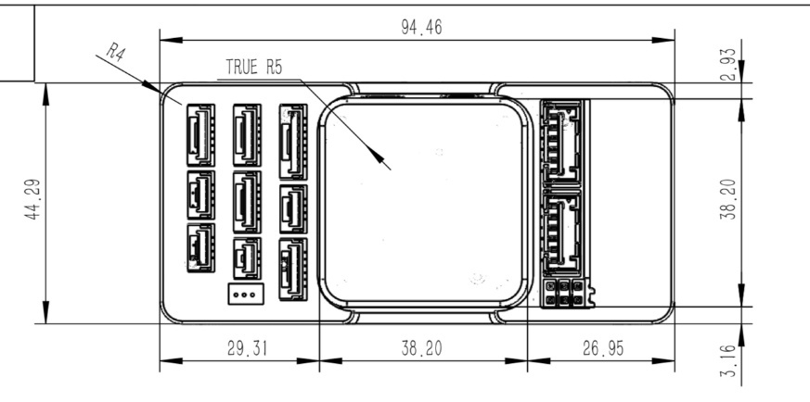

(II) CUAV
GPS provides real-time location data for features like autonomous flight, position hold, waypoint navigation, and return-to-home (RTH), ensuring stable outdoor flight.
We use the Here 3+ CAN GNSS module, which supports RTK for high-precision positioning, fast satellite lock, and reliable data via CAN interface enhancing accuracy, signal stability, and performance even in GPS-denied areas.
Specification
Positioning accuracy | 3D FIX: 2.5 m / RTK: 0.025 m
Processor | STM32H757
IMU sensor | ICM42688, RM3100
Operating Temperature | -40℃ to 85℃
Dimension | 68 x 68 x 16 mm
Weight | 51.8g

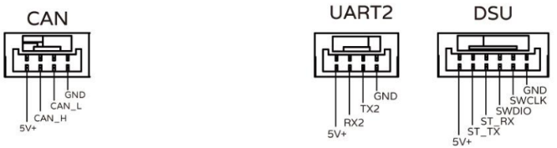
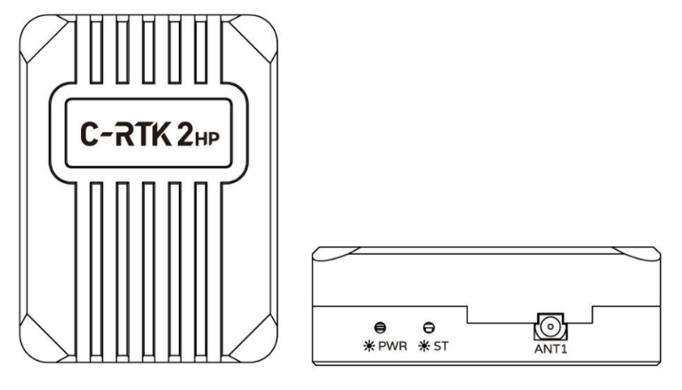
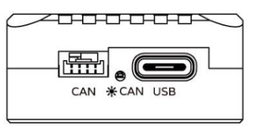
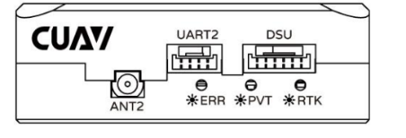
2D Drawing of Module:

(III) Raspberry Pi 5
Raspberry Pi serves as a companion computer for our multi-rotor UAV, handling AI-based computations such as target recognition.
We are using the Raspberry Pi 5, which processes visual data and communicates results to the Pixhawk Flight Controller via the serial port, enabling advanced autonomous functions.
Specification
Processor | Broadcom BCM2712, Quad-core 64-bit Arm Cortex-A76 @ 2.4GH
Ram | 8GB LPDDR4X-4267
GPU | VideoCore VII (Supports OpenGL ES 3.1, Dual 4Kp60 HDMI)
Storage | microSD slot (SDR104 support), PCIe 2.0 x1
Power Supply | 5V/5A via USB-C (PD supported)
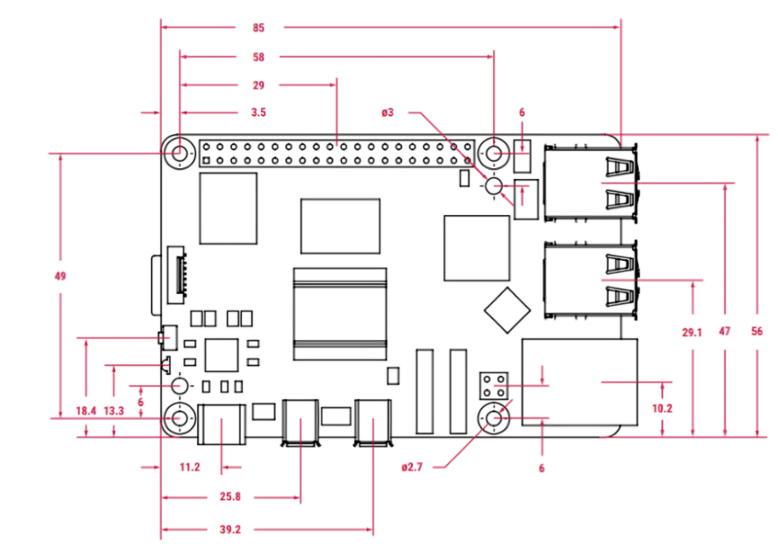
2D Drawing of Raspberry Pi

2.7.3 Avionics and sensors
The avionics system handles navigation, stabilization, communication, and data processing. Our drone's setup is chosen for reliability and precision, supporting advanced autonomous features for tasks like surveying.
S. no. | Components | Name
1 | Flight Controller | Pixhawk Cube 1Orange
2 | ESC (Electronic Speed Controller) | Cyclone 45A ESC
3 | Transmitter | Skydroid T10
4 | Receiver | T10 Reciever
A sensor in a drone is an electronic component that detects physical changes or conditions in the environment or the drone itself, then sends this data to the flight controller or other systems for processing.
S. no. | Components | Sensors
1 | C-RTK2 HP | RTK GPS Module  Compass RM3100
2 | Pixhawk Cube | 3x ICM-45686 Accelerometer/Gyroscope  Barometers: 2 x MS5611  Magnetometer: BMM150

2.8 Center of Gravity (C.G.) Estimation & Stability Analysis
The Centre of Gravity (CG) is crucial for UAV stability, ensuring balanced load across motors for better control and maneuverability.
For our UAV, the CG was determined using both CAD-based mass analysis (Fusion 360) and structural simulation software (ANSYS 2025 R1).
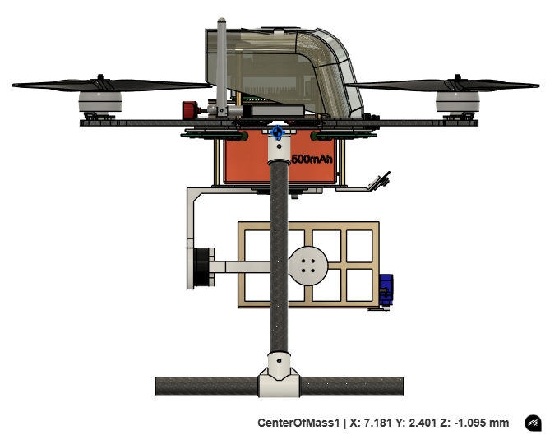
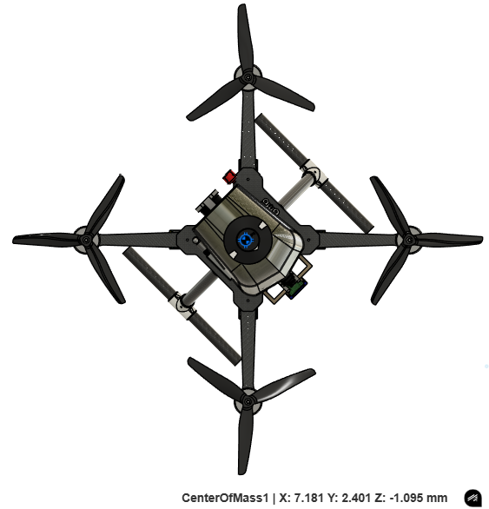
In Fusion 360, CG coordinates were: X = 7.181 mm, Y = 2.401 mm, Z = -1.095 mm

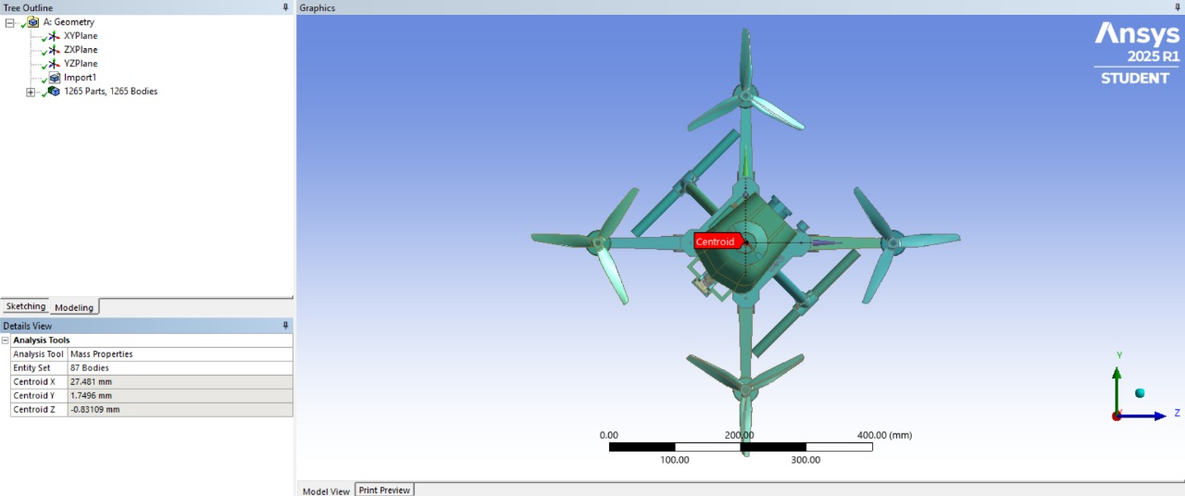
In ANSYS, CG coordinates were: X = 27.481 mm, Y = 1.7496 mm, Z = -0.8311 mm

2.9 Preliminary CAD Model
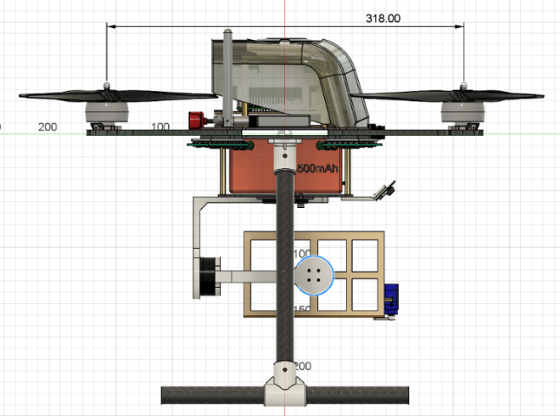
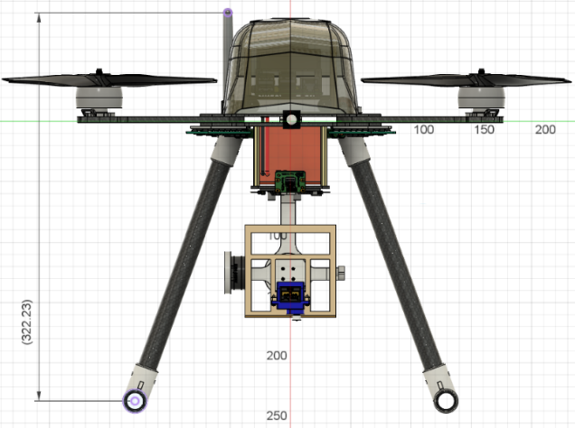
A Preliminary CAD Model of our drone refers to the initial 3D design created using CAD (Computer-Aided Design) software that represents the basic structure and components of the drone before final optimization and detailed engineering.

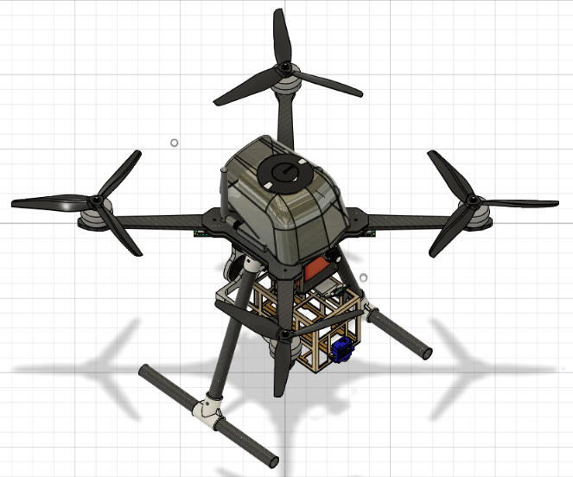
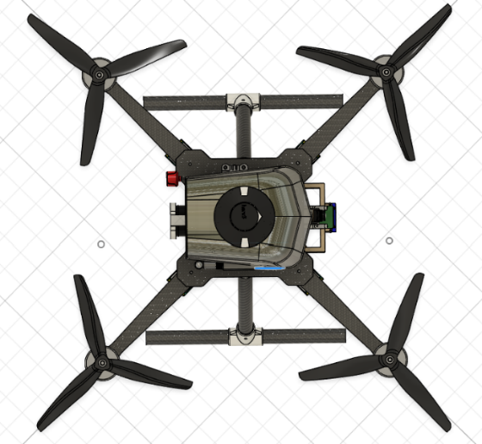
Front View Side View

Top View Angle View

2.10 Computational Analysis
STRUCTURAL ANALYSIS
In the structural analysis, a 60 N thrust force and a 20 N payload are applied to both the frame and the arm.
Total Deformation: Total Deformation is the magnitude of the total displacement of a point in all directions, showing how far that point has moved from its original position.
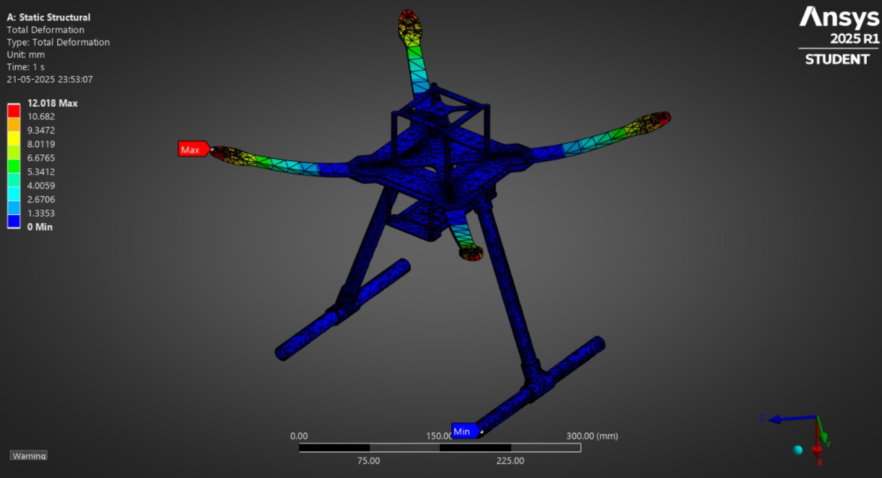
Frame
Maximum Deformation: 12.018
Minimum Deformation: 0 m
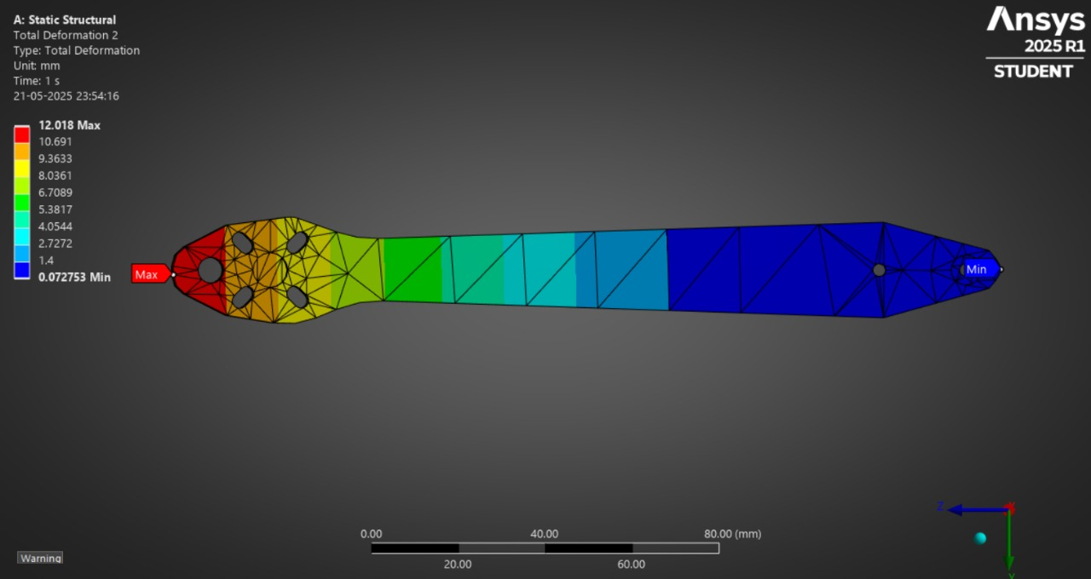
Arms
Maximum Deformation: 12.018 mm
Minimum Deformation: 0 mm
The simulation showed very little deformation in the Frame and Arms, which means the design is structurally strong.
Equivalent Elastic Strain: Equivalent Elastic Strain is the amount of strain energy per unit volume a material stores under elastic deformation, expressed as a single value, typically used for comparing to yield strain limits.
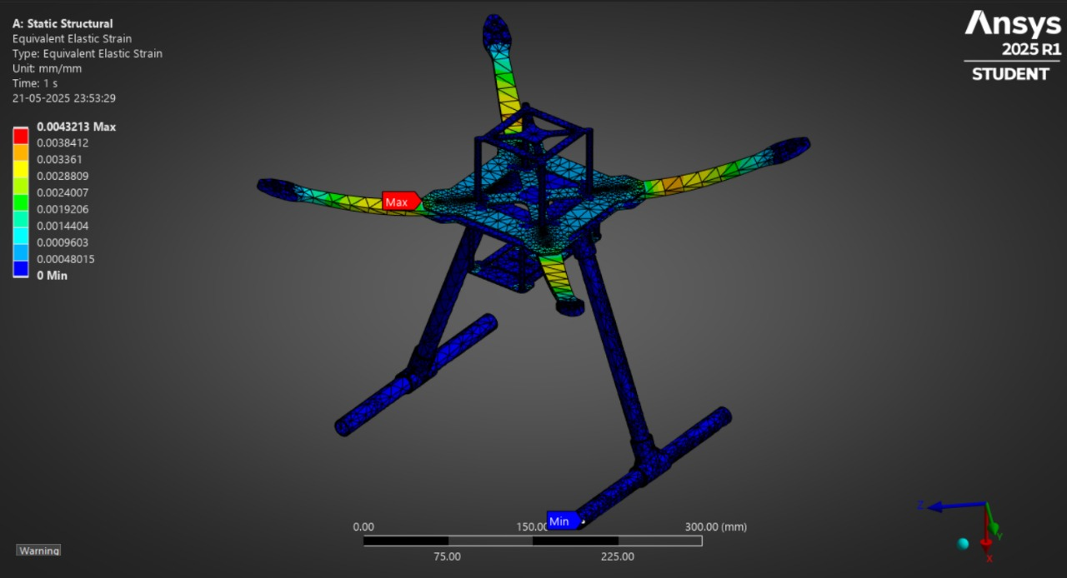
Frame
Maximum Elastic Strain: 0.0043213
Minimum Elastic Strain: 0
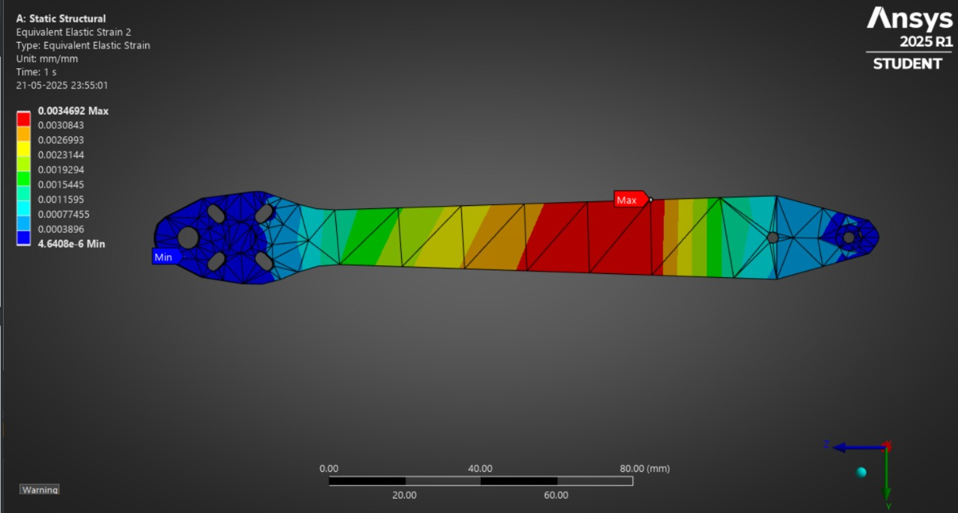
Arms
Maximum Elastic Strain: 0.0034692
Minimum Elastic Strain: 0
The strain values stayed within safe limits, indicating the material only experienced elastic deformation.
Equivalent Stress: Equivalent Stress (also known as von Mises stress) is a calculated value that combines the different normal and shear stress components into one value, making it easier to compare against the material's yield strength
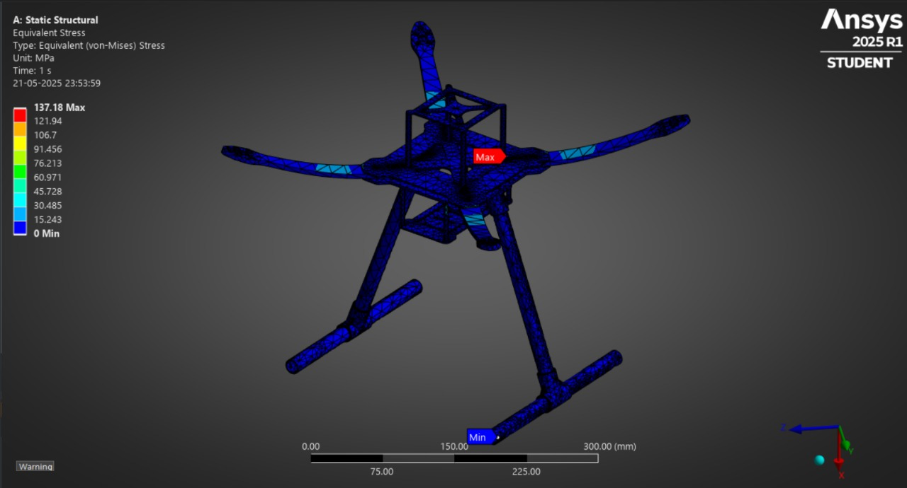
Frame
Maximum Elastic Strain: 137.18 MPa
Minimum Elastic Strain: 0
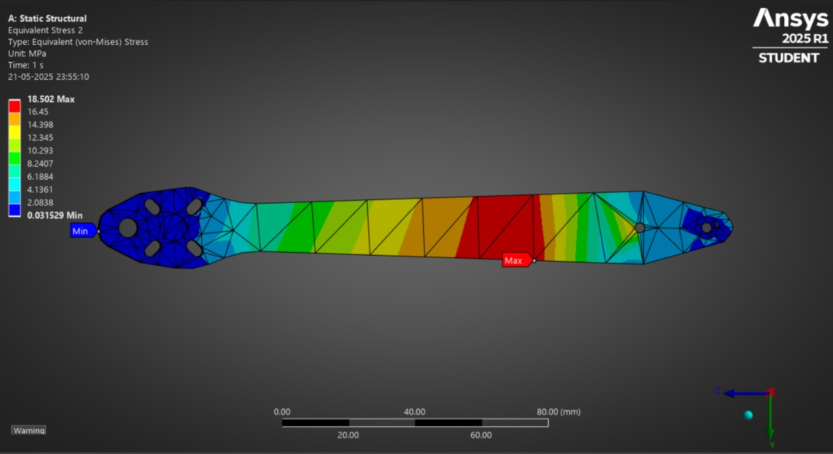
Arms
Maximum Elastic Strain: 18.502 MPa
Minimum Elastic Strain: 0
The stress values were all below the yield strength, confirming that the structure is safe under load.

2.11 Optimized Final Design
During the initial prototype phase, our drone was equipped with ReadytoSky OPTO 40A ESCs and a 5200 mAh 4S LiPo battery, contributing to a total takeoff weight of approximately 2100 g. This weight exceeded the Micro UAV category limit defined in the Aerothon competition rules. In response, we conducted a critical review of the propulsion-related components and implemented targeted optimizations to reduce overall weight without compromising performance.
By replacing the heavier OPTO ESCs with lightweight BLHeli ESCs and switching to a higher-capacity, lower-weight Li-ion battery, we successfully reduced the total UAV weight to ~1905 g, bringing it into the compliant range for Micro UAV classification.

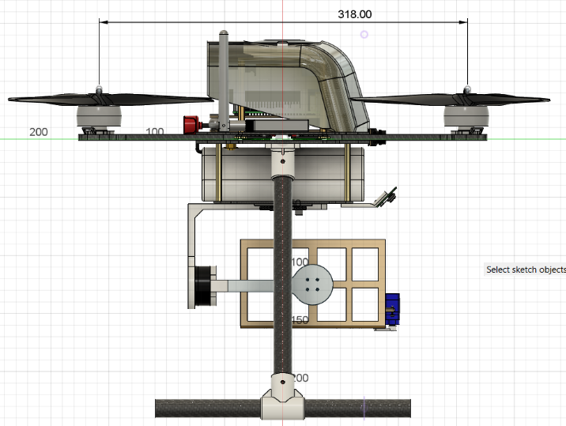
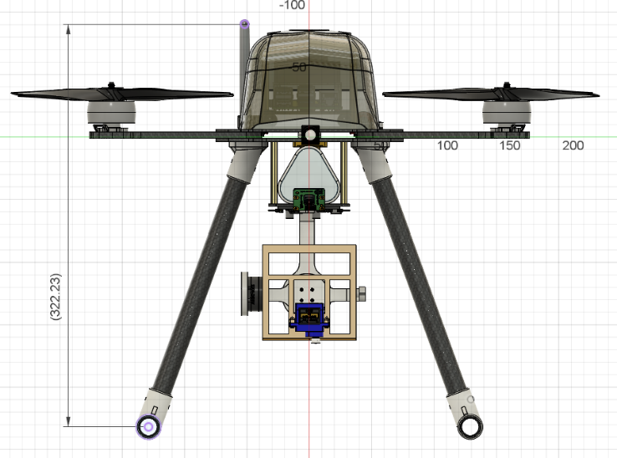
2.11.1 Final CAD model

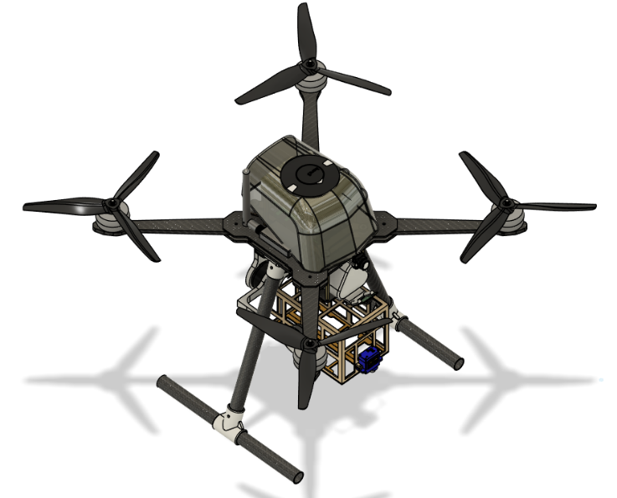
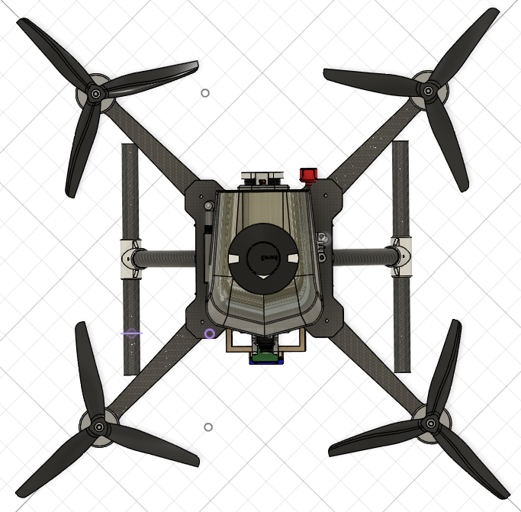
Front View Side View

Top View Angle View

2.11.2 Final 2D drafting
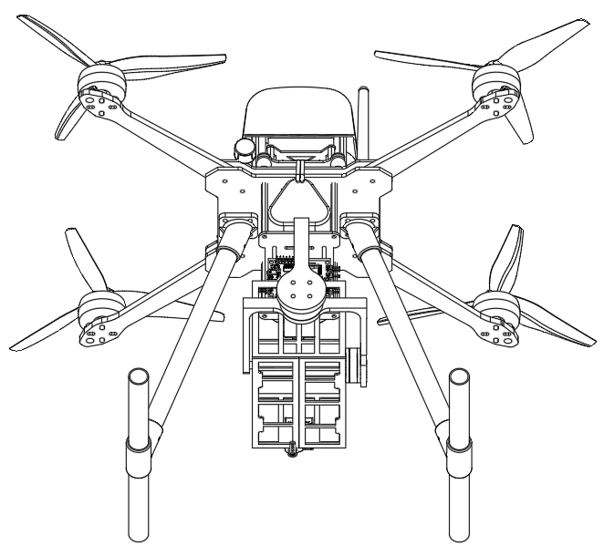
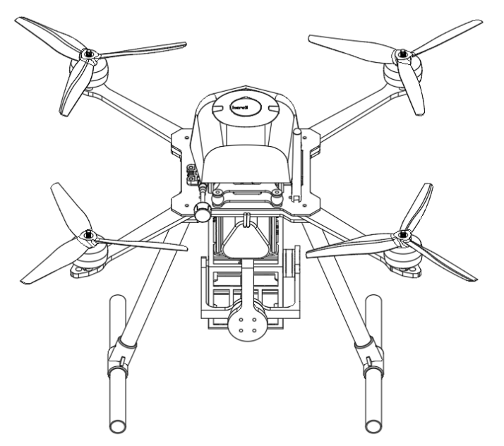

Back View Bottom View
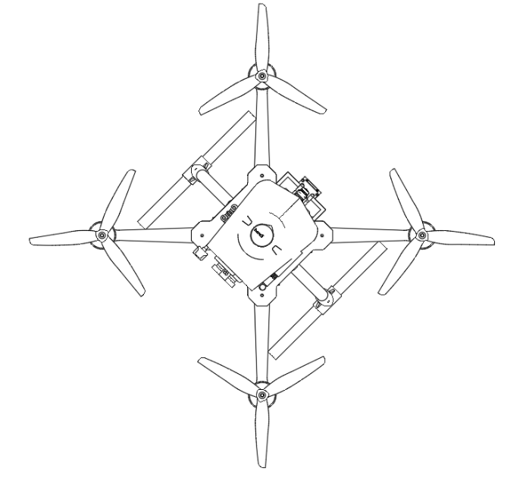
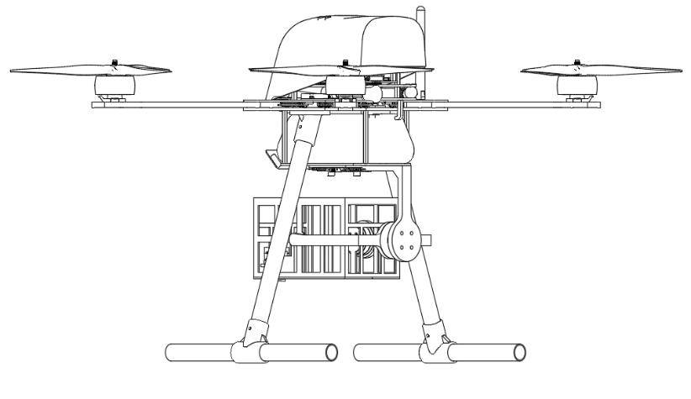

Top View Side View

2.11.3 Updated C.G. analysis
The updated CG was determined using both CAD-based mass analysis (Fusion 360) and structural simulation software (ANSYS 2025 R1).
In Fusion 360, the full assembly, electronic components, frame, and propeller systems was considered for CG calculation.
The computed CG coordinates were: X = 7.181 mm, Y = 2.401 mm, Z = -1.095 mm
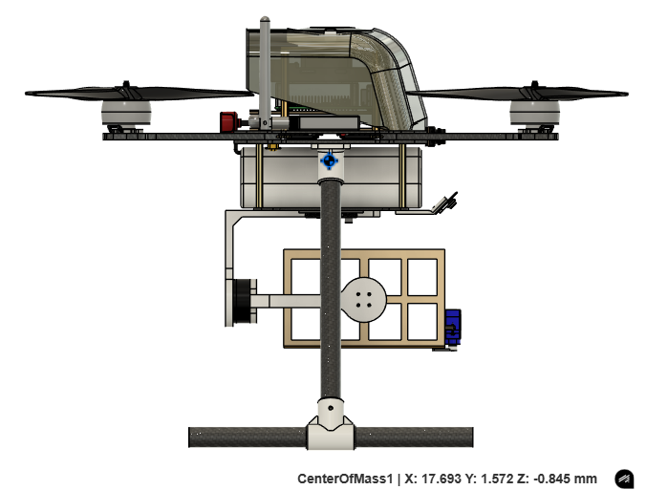
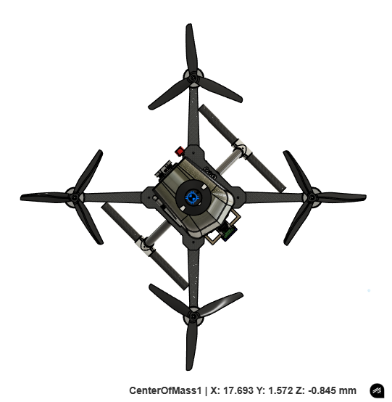

In ANSYS, a static structural analysis was performed considering the mass distribution of the frame structure.
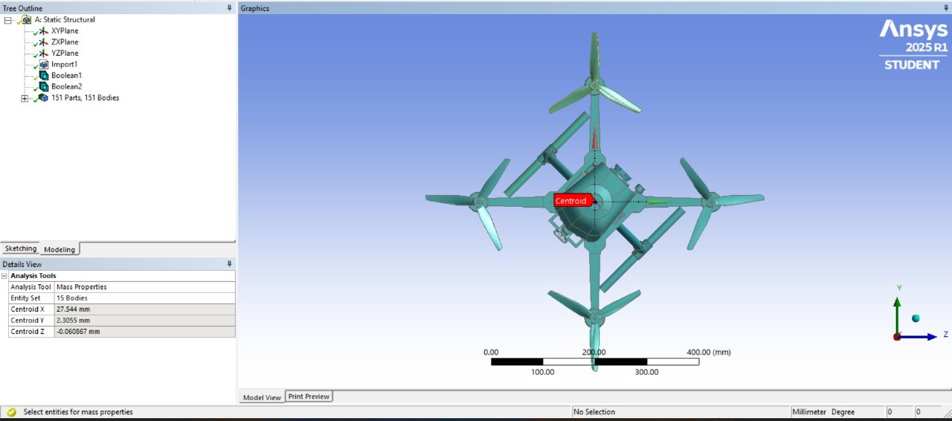
The calculated centroid coordinates were: X = 27.544 mm, Y = 2.3055 mm, Z = -0.0608 mm

2.12 Detailed Weight Breakdown & C.G. Analysis
After upgrading to Cyclone 45A ESCs (6g each) and a 9000mAh 3s Li-ion battery (440g), which is significantly lighter than the previous setup, the overall weight of the drone has been reduced, resulting in improved flight endurance.
Detailed Weight Breakdown
Components | No. of Units | Unit Weight  (in grams) | Total Weight  (in grams)
Flight Controller | 1 | 74 | 74
BLDC Motor | 4 | 80 | 320
Propeller | 4 | 13 | 52
ESC | 4 | 6 | 24
Receiver | 1 | 0.6 | 0.6
Telemetry | 1 | 21 | 21
GPS | 1 | 52 | 52
Flight Computer | 1 | 105 | 105
Camera | 1 | 9 | 9
FPV Camera | 1 | 9 | 9
VTX | 1 | 5.6 | 5.6
VTX Antenna | 1 | 7.8 | 7.8
Gimbal Motor 1 | 1 | 26 | 26
Gimbal Motor 2 | 1 | 40 | 40
Gimbal Controller | 1 | 10 | 10
Servo Motor | 1 | 9 | 9
Battery | 1 | 440 | 440
Frame + Landing Gear | 1 | ~420 | ~420
Gimbal | 1 | ~80 | ~80
Payload | 1 | 200 | 200
 | Total Weight |  | ~1905g

C.G. Analysis
Shown here is the CG location of our UAV, calculated using ANSYS structural analysis.
The calculated centroid coordinates were: X = 27.544 mm, Y = 2.3055 mm, Z = -0.0608 mm

2.12 UAS Performance Recalculation

2.12.1 Thrust-to-weight ratio
The thrust-to-weight ratio (TWR) is a key performance indicator that compares the total thrust generated by the drone’s motors to its overall weight. It determines the drone’s ability to take off, climb, and carry payloads efficiently. A higher TWR indicates better lift, agility, and responsiveness during flight.
For the proposed quadrotor using Hobbywing X6 Plus motors with ~22–24 inch propellers, the system achieves an estimated thrust-to-weight ratio of approximately 3.7:1. This provides sufficient thrust margin for quick take off, stable hovering, and reliable payload delivery, making the UAV suitable for disaster management operations.
Propeller | Thrust | Voltage | Current | Power | TWR
2480 | ~11.8kg (Max at this Power) | 46V (max) | 51.8A | ~2398W | ~2.6:1

2.12.2 Power requirements for the mission
S. no. | Components | Name | Operating Voltage  (V) | Operating Current (A) | Power Consumption (w)
1 | Flight Controller | Cube | 6 | 1.5 | 9.0
2 | BLDC Motors (x4) | X6 Plus | 46 | 51.8 | 2392
3 | ESC | Integrted in motor | - | - | - (included in motor draw)
4 | Receiver | T10 RX | 5 | 0.1 | 0.5
5 | RTK GPS | Cuav 2hp | 5 | 0.15 | 0.75
6 | Flight Computer | Raspberry Pi 5 8GB | 5 | 3 | 15.0
 | Total…………... |  |  | 56.55A (max) | 2417.25 W (max)

`2.12.3 Endurance Calculation
After replacing the ESC and battery with more efficient and higher-capacity ones, our drone can now fly for a longer time, which improves its performance during tasks.
The Estimated calculation for endurance is hereby: -
Endurance (hrs.) = Battery Capacity (Ah) / Current Drawn (A)
According to the power required estimated values, the calculated endurance is: -
Endurance (min.) = (9(Ah) / 27(A)) * 60
Endurance (min.) = 15.5 min

(3) Final UAS Specifications and Bill of Materials (BoM)
Components | Specification/Model | Qty | Unit Cost | Total Cost
Motor | Xing2 3110 BLDC Motor | 4 | 4,400 | 17,600
ESC | Cyclone 45A ESC | 4 | 1100 | 4,400
Flight Controller | Pixhawk 6X V2B | 1 | 35,000 | 35,000
Flight Computer | Raspberry Pi 5 8GB | 1 | 5,500 | 5,500
GPS | Here 3+ GPS Module RTK Support | 1 | 24,500 | 24,500
Transmitter | Radiomaster TX16S | 1 | 23,000 | 23,000
Receiver | Radiomaster RP2 V2 ELRS | 1 | 2,000 | 2,000
Propeller | HQ Prop 8*4*3 | 1 | 300 | 300
Battery | Li-ion Battery 9000 mAh (3S) | 1 | 3,500 | 3,500
Telemetry | Holybro Telemetry V3 500mW | 1 | 6,000 | 6,000
Camera | Arducam 64MP | 1 | 8,500 | 8,500
Servo | Servo SG90 | 1 | 100 | 100
VTX | Speedybee TX800 | 1 | 3,100 | 3,100
FPV Camera | RunCam Phoenix 2 JB | 1 | 3,900 | 3,900
Antenna | Foxeer Lollipop 4 RPSMA | 1 | 2,000 | 2,000
Wi-Fi Adaptor | TP-Link Wi-Fi Adapter | 1 | 1,200 | 1,200
PDB | Power Distribution Board 100A | 1 | 100 | 100
Gimbal Motor 1 | 2204 260KV BLDC Motor | 1 | 800 | 800
Gimbal Motor 2 | 2805 140KV BLDC Motor | 1 | 900 | 900
Controller Board | BGC 2-axis Controller Board | 1 | 1,200 | 1,200
Frame | Carbon Fiber | 1 | 6,500 | 6,500
Total…... |  |  |  | 1,50,100

(4) Methodology for Autonomous Operations

4.1 Detailed Methodology for Implementing Autonomous Flight
Our UAV system integrates a Raspberry Pi 5 as the companion computer, connected with an Arducam 64MP autofocus camera to handle high-resolution image acquisition and onboard computation. The system leverages DroneKit Python scripts to automate flight operations, and communicates with the Pixhawk flight controller using the MAVLink protocol. This architecture allows real-time mission control, telemetry handling, and sensor integration for both surveying and disaster response missions.

4.2 Surveying Method and Autonomous Data Collection
Geofence Integration: Geofence coordinates define the operational boundary of the mission and are uploaded to the drone's flight controller via DroneKit and Mission Planner software. This ensures the UAV remains within designated safety perimeters during autonomous missions.
Zigzag Path Planning: To guarantee complete coverage of the survey area, a zigzag flight pattern is implemented. This path ensures parallel-line traversal that spans the geofenced area, minimizing blind spots and ensuring efficient area mapping.
Camera and Imaging Setup: An Arducam 64MP autofocus camera is mounted downward-facing to capture high-resolution images. Due to vibration concerns, real-time object detection is avoided. Instead, images are taken at consistent intervals and stored for offline processing.
Takeoff and Landing: Both are fully autonomous using pre-configured flight modes, enabling seamless mission execution.

4.3 Techniques for Autonomous Object or Target Identification
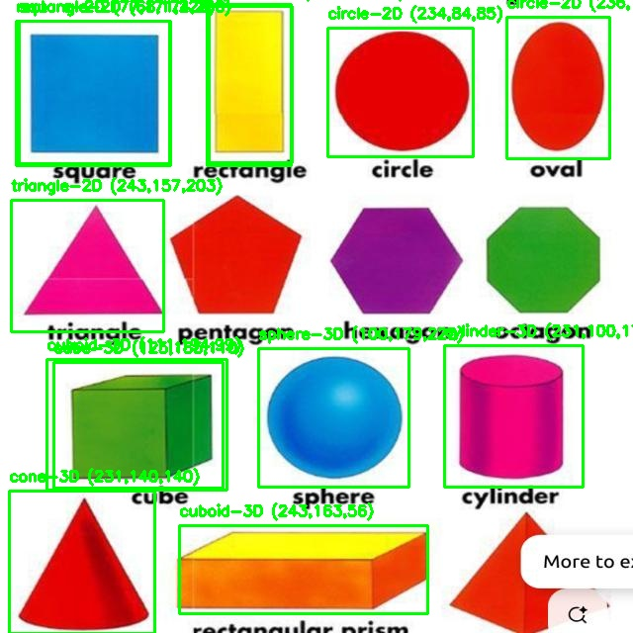
Model Used: A YOLOv8 custom-trained object detection model is deployed to classify detected entities. The model is trained to distinguish between:

• Shape: e.g., circle, square, cone, sphere, etc.
• Dimensionality: 2D (circle, square) vs. 3D (cube, cone, cylinder)
Training Results:
• mAP@0.5: ~0.58
• mAP@0.5:0.95: ~0.36
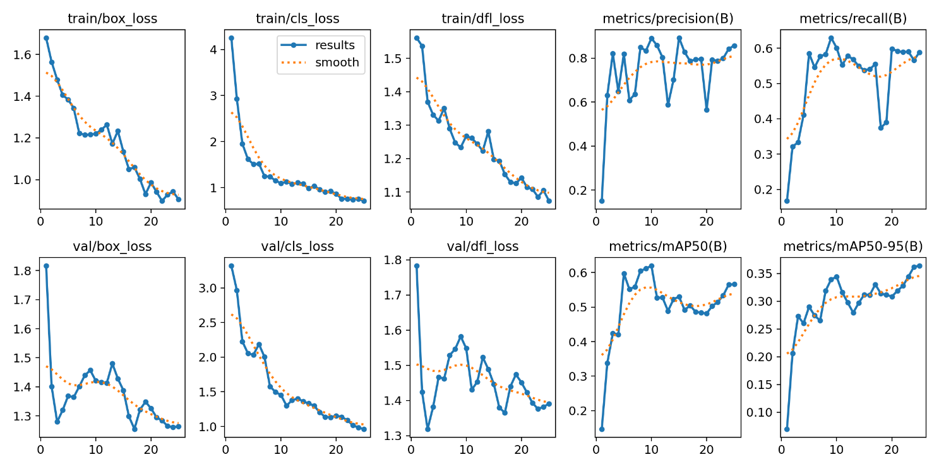
These results reflect moderate detection accuracy, suitable for deployment in semi-structured environments.
Processing Strategy:
• Frame-by-frame images are fed into the YOLOv8 model.
• Detected objects are filtered using confidence thresholds (>80%).
• Duplicate detections are suppressed using spatial clustering and distance thresholds.
Colour Identification:
Using OpenCV HSV filtering, each detected object is classified by colour (e.g., red, blue, green, yellow). Colour plays a key role in verifying object categories during missions.
Geotagging and Counting: Using RTK GPS, each unique object is precisely geolocated. This enables accurate object counts and spatial indexing of detected targets.

4.4 Disaster Management and Response
Disaster Detection Module: To enable disaster zone identification, we deployed a pretrained CNN-based image classification model on Raspberry Pi 5. This model processes live frames from the downward-facing camera and classifies them into categories such as fire, flood, smoke. The CNN was trained on a labeled dataset of aerial disaster imagery and fine-tuned for inference under UAV flight conditions.
High-Confidence Detection and Safe Drop: When the model detects a disaster with high confidence (>80%), the UAV scans for a nearby safe area such as dry land, green zones, or rooftops. Once a safe drop zone is identified, the UAV positions itself above the target using GPS hold delivers the safety equipment using a servo-controlled drop mechanism.
Post-Drop Action: After payload deployment, the drone either resumes its programmed mission path or executes an automatic RTL (Return to Launch).

(5) Summary of Innovations

5.1 Payload box with Gyroscope
In our innovative UAS design, we have developed a gyroscope-stabilized payload-carrying mechanism that ensures controlled and stable delivery of payloads, even under dynamic flight conditions. This system is centered around a gimbal controller, which processes real-time data from an integrated gyroscope sensor embedded within the payload box. The sensor continuously monitors the drone's angular momentum and orientation, allowing the system to detect any instability or tilt during flight or payload release. To actively maintain stability, gimbal motors adjust the orientation of the payload box, ensuring that it remains level throughout the flight and that the payload is released from an optimized, stable position. This approach effectively minimizes the risk of swinging, drifting, or damage to sensitive items during delivery.
Benefits of the Innovation
(I) Enhanced Stability:
The gyroscope-controlled stabilization significantly reduces unwanted rotations and compensates for drone movement, ensuring a smooth and stable drop. This minimizes the risk of damage to sensitive or fragile payloads.
(II) Versatility:
The system is adaptable to a wide range of payload types and delivery scenarios, making it suitable for diverse applications such as humanitarian aid, emergency relief, and commercial drone deliveries.
(II) Improved Accuracy:
Real-time orientation control allows the payload to be released from an optimal position, enhancing drop precision even in unstable or windy conditions.
(IV) Modular Design:
The payload box and gimbal mechanism are designed to be modular and customizable, allowing for easy integration with different drone platforms and mission-specific requirements.
(V) Real-Time Response:
The gimbal controller processes gyroscope data in real time, enabling immediate adjustments during flight for improved performance during dynamic operations.
(VI) Increased Safety:
Controlled and stable payload release reduces swinging and accidental drops, enhancing safety for both the payload and surrounding environment.
Key Components
S. no. | Components | Description
1 | Gimbal Motor 1 | 2204 260KV BLDC Motor
2 | Gimbal Motor 1 | 2805 140KV BLDC Motor
3 | Gimbal Controller | BGC 2-axis Controller Board
4 | Servo Motor | TowerPro SG90
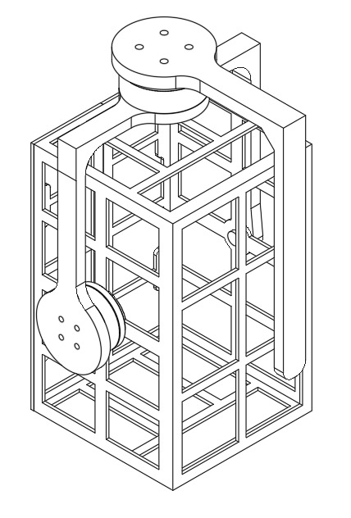
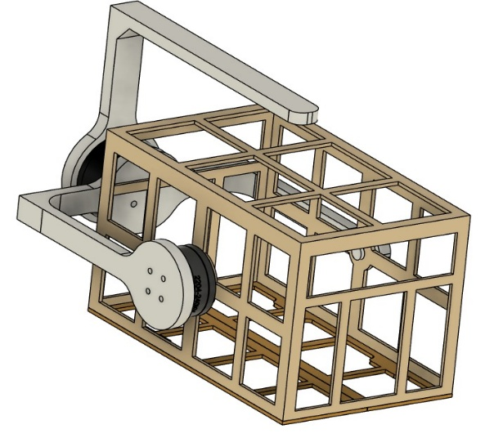
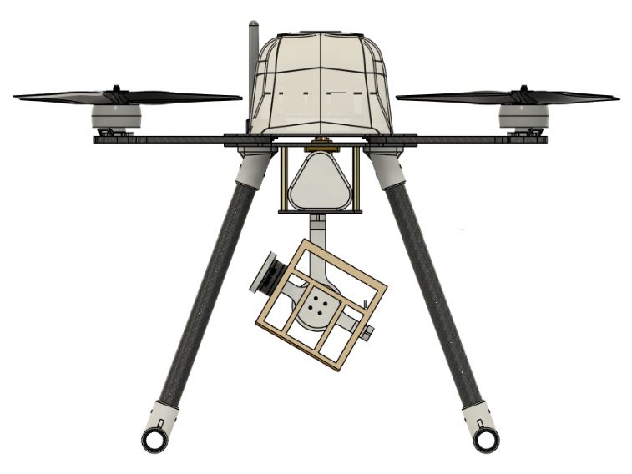
2D and 3D Drawing of Payload box with Gyroscope
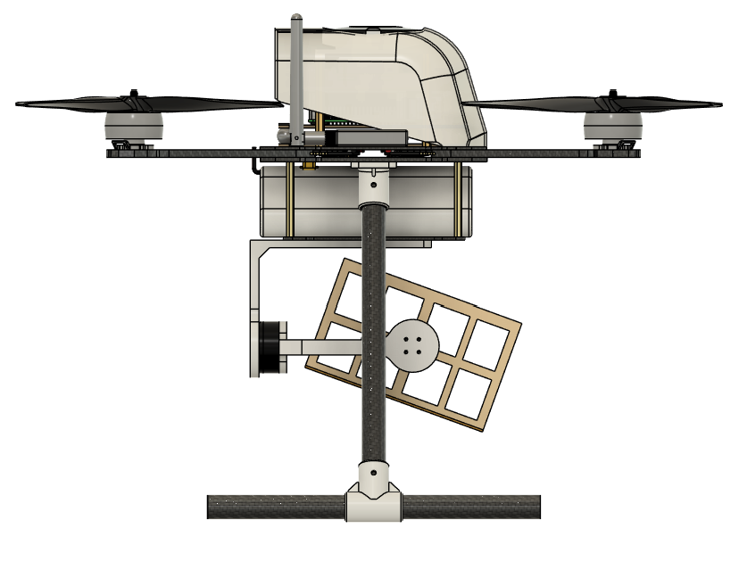

Front View Side View

(6) References

1. Dhwanil Shukla, Narayanan Komerath, "Multirotor Drone Aerodynamic Interaction Investigation".
2. Mingfeng Wang, José-Alfredo Leal-Naranjo, Marco Ceccarelli, Simon Blackmore, "A Novel Two-Degree-of-Freedom Gimbal for Dynamic Laser Weeding: Design,Analysis, and Experimentation," IEEE.
3. Shriharsha S. Veni, Ananda S. Hiremath, Mahalakshmi Patil, Mayuri Shinde, Aishwarya Teli, "Video-Based Detection, Counting and Classification of Vehicles Using OpenCV," ICICNIS 2020, 8 pages, posted January 20, 2021. Written January 19, 2021.
4. Aditya Amoriya, Chandan Kumar, Savita Kumari, "Counting Number of Objects in Images Using Machine Learning," IEEE.
5. Chaoyu Lin, Yuliang Tang, "Research and design of the intelligent surveillance system based on DirectShow and OpenCV," IEEE.
6. http://rcbenchmark.com/
7. Yun Li, Kiam Heong Ang, G.C.Y. Chong, "PID control system analysis and design," IEEE.
8. Daniel Farbman, Chris McCoy, "Materials Testing of 3D Printed ABS and PLA Samples to Guide Mechanical Design".
9. Zahid Ali Siddiqui, Unsang Park, "A Drone Based Transmission Line Components Inspection System with Deep Learning Technique".
10. Giuseppe Silano, Pasquale Oppido, Luigi Iannelli, "Software-in-the-loop Simulation for Improving Flight Control System Design: A Quadrotor Case Study," IEEE.
11. Enrica Soria, Fabrizio Schiano, Dario Floreano, "SwarmLab: A Matlab Drone Swarm Simulator," IEEE.

